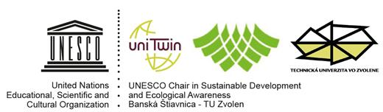
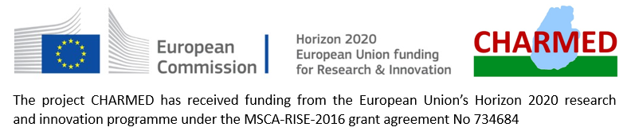
Magyar Professzorok Nemzetközi Szövetsége
International Association of Hungarian Professors
Association Internationale des Professeurs Hongrois d’Université
)

and Slovak Commission for UNESCO

6th International Conference
under the auspice of the Ministry of Environment of SR

Selected Aspects of Integrated Environmental Management
„State of the environment - manifestation of natural and cultural heritage“

VI. medzinárodná vedecká konferencia
pod záštitou Ministerstva životného prostredia SR

Vybrané aspekty integrovaného manažmentu
životného prostredia
„Stav životného prostredia – prejav prírodného a kultúrneho dedičstva“

Zvolen
11th – 12th October, 2018

Slovak Commission for UNESCO
UNESCO-Chair for Ecological Awareness and Sustainable Development
of Faculty of Ecology and Environmental Sciences, Technical University in Zvolen
in cooperation with
Global Water Partnership Slovakia
Project Horizon 2000 MSCA-RISED-2016 No 734684 – CHARMED
International Association of Hungarian Professors
under the auspices of
Ministry of the Environment of Slovak Republic

kindly invite you to the

6th International Conference
Selected Aspects of Integrated Environmental Management
„State of the environment - manifestation of natural and cultural heritage“

The conference will include following topics:
I. BLOCK - Legal and economical aspects of the cultural and natural heritage
II. BLOCK - Landscape-ecological aspects of cultural and natural heritage
III. BLOCK - Environmental aspects of cultural and natural heritage
IV. BLOCK - Educational aspects of management of cultural and natural heritage

Target group:
scientific and professional public, non-governmental organizations, governmental authorities, self-government, environmental stakeholders, action groups in landscape planning, landscape management and tourism

Scientific committee:
Dr.h.c. prof. RNDr. László Miklós, DrSc. (miklos@tuzvo.sk)
RNDr. Tomáš Orfánus, PhD. (Tomas.Orfanus@savba.sk)
Organizational committee:
Ing. Andrea Diviaková, PhD. (diviakova@tuzvo.sk), Miroslava Ružinská (ruzinska@tuzvo.sk),
Ing. Magdaléna Pichlerová, PhD. (magdalena.pichlerova@tuzvo.sk), Ing. Eliška Belaňová, PhD. (eliskabelanova@gmail.com), doc. Ingrid Belčáková, PhD. (belcakovaingrid@gmail.com),
RNDr. Anna Špinerová, PhD. (spinerova@tuzvo.sk), Ing. Monika Offertálerová (monika.off@centrum.sk), Ing.arch. Ján Špiner (janspiner@gmail.com).

Venue and date: Technical University in Zvolen, October 11 – 12, 2018
Conference language: Slovak, Czech, English
Registration submission deadline: July 27, 2018
Paper submission deadline: August 21, 2018
Contact: diviakova@tuzvo.sk, ruzinska@tuzvo.sk, magdalena.pichlerova@tuzvo.sk, phone: +421 45 5206 583, +421 45 5206 563, +421 45 5206 192
Conference fee: 50 €/students 20 € (including conference costs, proceedings, refreshment, excursion)
Conference fee deadline: August 21, 2018
Accommodation and meal should be covered by participants. In case of your interest, the organizing committee is happy to help you with accommodation and meal booking at Bariny student residence.

Conference Draft Programme

October 11, 2018

9⁰⁰ – 10⁰⁰ Registration

10⁰⁰ – 10¹⁵ Conference welcome

10¹⁵ – 12⁰⁰ TOPIC I presentations „Legislation and economical aspects of the relationship of cultural and natural heritage “

12⁰⁰ – 13⁰⁰ Lunch

13⁰⁰ – 14³⁰ TOPIC II presentations „Landscape-ecological aspects of management of cultural and natural heritage “

14³⁰ – 15³⁰ TOPIC III presentations „Environmental aspects of cultural and natural heritage “

16³⁰ – 17⁰⁰ Break, refreshment

17⁰⁰ – 17³⁰ TOPIC IV presentations „Educational aspects of management of cultural and natural heritage “

17³⁰ – 18⁰⁰ Discussion

18⁰⁰ – 18³⁰ Poster presentation

19⁰⁰ Dinner (according to request)

October 12, 2018

9⁰⁰ – 13⁰⁰ Field excursion: UNESCO World Cultural and Natural Heritage site Banská Štiavnica and surrounding technicaal monuments

Contributions will be published as chapters in monograph. Instructions for authors will be sent in the 2nd Circular.

Programme will be modified according to applied papers
and participants interests for an excursion.

Registration Form

6th International Scientific Conference
Selected Aspects of Integrated Environmental Management

Zvolen
11-12 October, 2018

1. Last name:

2. First name

3. Professional title

4. Institution

5. Position

6. Title of paper

7. Title of poster

8. Postal address

9. E-mail, phone
10. Field excursion | 12.10.2018  Yes/No
11. Accomodation in student residence Bariny | 10.10.2018 11.10.2018 12.10.2018  Yes/No Yes/No Yes/No
12. Lunch in student residence Bariny | 11.10.2018  Yes/No

Provider of services:

UNIVERZITNÁ VEDECKOTECHNICKÁ SPOLOČNOSŤ TECHNICKÁ UNIVERZITA VO ZVOLENE

T.G.Masaryka 24, 960 53 ZVOLEN, č.t. 045/5206281

Account name: Univerzitná vedeckotechnická spoločnosť Technická univerzita Zvolen

Bank: SLSP, a.s. Zvolen

Account No. IBAN: SK5709000000000071635417

BIC-SWIFT Code: GIBASKBX

Variable symbol: 806/18

IČO: 35986433; DIČ: 2021433425

Information for receiver: your name

Contact: diviakova@tuzvo.sk, ruzinska@tuzvo.sk, tel. 045/5206583, 045/5206563

